

8 Week SQL Challenge: CaseStudy 1 Danny’s Diner

Danny wants to use the data to answer a few simple questions about his customers, especially about their visiting patterns, how much money they’ve spent and also which menu items are their favourite. Having this deeper connection with his customers will help him deliver a better and more personalised experience for his loyal customers.

He plans on using these insights to help him decide whether he should expand the existing customer loyalty program - additionally he needs help to generate some basic datasets so his team can easily inspect the data without needing to use SQL.

Danny has provided you with a sample of his overall customer data due to privacy issues - but he hopes that these examples are enough for you to write fully functioning SQL queries to help him answer his questions!

Danny has shared with you 3 key datasets for this case study:

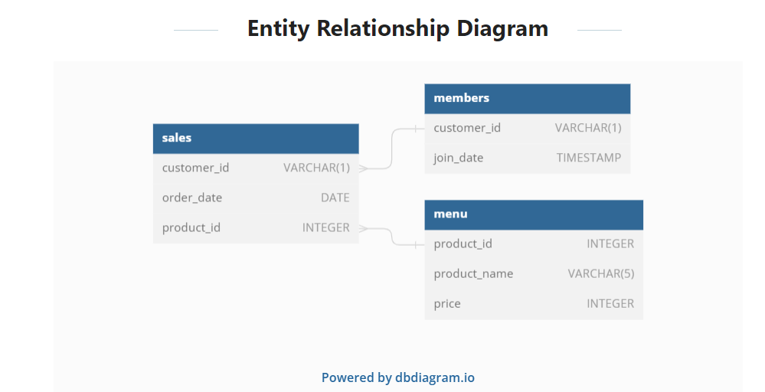

**CREATE** **SCHEMA** dannys_diner;

**SET** search_path = dannys_diner;

**CREATE** **TABLE** sales (

"customerid" VARCHAR(1),

"order_date" DATE,

"product_id" INTEGER);

**INSERT** **INTO** sales

("customerid", "order_date", "product_id")

**VALUES**

('A', '2021-01-01', '1'),

('A', '2021-01-01', '2'),

('A', '2021-01-07', '2'),

('A', '2021-01-10', '3'),

('A', '2021-01-11', '3'),

('A', '2021-01-11', '3'),

('B', '2021-01-01', '2'),

('B', '2021-01-02', '2'),

('B', '2021-01-04', '1'),

('B', '2021-01-11', '1'),

('B', '2021-01-16', '3'),

('B', '2021-02-01', '3'),

('C', '2021-01-01', '3'),

('C', '2021-01-01', '3'),

('C', '2021-01-07', '3');

**CREATE** **TABLE** menu (

"product_id" INTEGER,

"product_name" VARCHAR(5),

"price" INTEGER

);

**INSERT** **INTO** menu

("product_id", "product_name", "price")

**VALUES**

('1', 'sushi', '10'),

('2', 'curry', '15'),

('3', 'ramen', '12');

**CREATE** **TABLE** members (

"customerid" VARCHAR(1),

"join_date" DATE

);

**INSERT** **INTO** members

("customer_id", "join_date")

**VALUES**

('A', '2021-01-07'),

('B', '2021-01-09');

--*Q1 What is the total amount each customer spent at the restaurant?*

SELECT customerid, SUM(m.price) FROM sales as s

INNER JOIN menu as m ON s.product_id = m.product_id GROUP BY customerid;

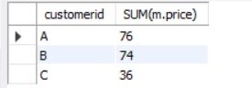

--*Q2 How many days has each customer visited the restaurant?*

SELECT customerid, COUNT(DISTINCT(order_date)) FROM sales GROUP BY customerid;

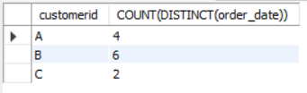

--Q3 *What was the first item from the menu purchased by each customer?*

WITH cte AS (

SELECT customerid, order_date, SALES.product_id, product_name,

DENSE_RANK() over (PARTITION BY customerid ORDER BY order_date) AS DENSERANK

FROM sales INNER JOIN menu ON sales.product_id = menu.product_id)

SELECT customerid, product_name FROM cte WHERE denserank = 1

GROUP BY customerid, product_name;

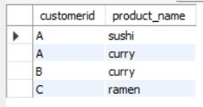

--Q4 *What is the most purchased item on the menu and how many times was it purchased by all customers?*

SELECT product_name, COUNT(sales.product_id) AS no_of_times_ordered

FROM sales JOIN menu

ON sales.product_id = menu.product_id

GROUP BY menu.product_name ORDER BY no_of_times_ordered DESC LIMIT 1;



--Q5 *Which item was the most popular for each customer?*

WITH food_popularity AS (

SELECT sales.customerid, menu.product_name,

COUNT(SALES.product_id) AS ordcount,

DENSE_RANK() over (PARTITION BY sales.customerid ORDER BY COUNT(sales.product_id) DESC) AS popularity

FROM sales JOIN menu ON sales.product_id = menu.product_id

GROUP BY sales.customerid, menu.product_name)

SELECT customerid, product_name, ordcount FROM food_popularity

WHERE POPULARITY = 1;

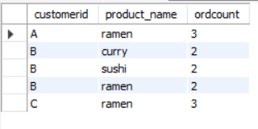

--Q6 *Which item was purchased first by the customer after they became a member?*

select members.customerid, order_date, product_id,row_number() over (partition by members.customerid order by order_date) AS row_num

from sales JOIN members ON sales.customerid = members.customerid WHERE order_date>join_date

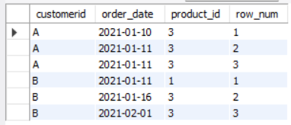

--Q7 *Which item was purchased just before the customer became a member?*

WITH cte AS (

SELECT members.customerid, order_date, product_id,ROW_NUMBER() OVER (PARTITION BY members.customerid ORDER BY order_date DESC) AS row_num

FROM sales JOIN members ON sales.customerid = members.customerid

WHERE order_date<join_date)

SELECT cte.customerid, cte.product_id, product_name FROM cte JOIN menu

ON cte.product_id = menu.product_id WHERE row_num = 1 ORDER BY customerid;

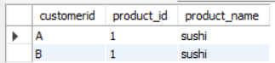

--Q8 *What is the total items and amount spent for each member before they became a member?*

SELECT sales.customerid, COUNT(sales.product_id) AS count ,SUM(menu.price) AS total

FROM sales JOIN members ON sales.customerid = members.customerid AND join_date>order_date

JOIN menu ON sales.product_id = menu.product_id

GROUP BY sales.customerid

ORDER BY sales.customerid

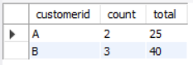

--Q9 *If each $1 spent equates to 10 points and sushi has a 2x points multiplier - how many points would each customer have?*

WITH points_cte AS (

SELECT menu.product_id, CASE WHEN product_id = 1 THEN price * 20 ELSE price * 10 END AS points FROM dannys_diner.menu)

SELECT sales.customerid, SUM(points_cte.points) AS total_points

FROM dannys_diner.sales JOIN points_cte ON sales.product_id = points_cte.product_id

GROUP BY sales.customerid ORDER BY sales.customerid;

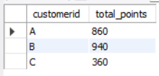

--Q10 *In the first week after a customer joins the program (including their join date) they earn 2x points on all items, not just sushi - how many points do customer A and B have at the end of January?*

SELECT s.customerid,

SUM(IF(order_date BETWEEN join_date AND DATE_ADD(join_date, INTERVAL 6 DAY), price*10*2, IF(product_name = 'sushi', price*10*2, price*10))) AS customer_points

FROM dannys_diner.menu AS m INNER JOIN dannys_diner.sales AS s ON m.product_id = s.product_id

INNER JOIN dannys_diner.members AS mem USING (customerid)

WHERE order_date <='2021-01-31' AND order_date >=join_date

GROUP BY s.customerid ORDER BY s.customerid;

